**Problème statement :**

The problem: The rapid development of Generative Pre-trained Transformer (GPT) artificial intelligence (AI) technology has a great impact on the education of IT students in universities. (GPT) AI gives students hands-on experience with cutting-edge technology and the opportunity to work on real-life projects, however it also brings challenges and potential downsides.

Integrating (GPT) AI into the curriculum alone may not be enough to equip students with the skills they need to succeed in the rapidly evolving technology field. There is a risk that IT students will be overwhelmed by the sheer volume of information and have a hard time keeping up with the pace of technological advancement.

Additionally, the use of (GPT) AI in education can also raise ethical concerns, especially around issues such as privacy, data security, and algorithmic bias. IT students should be equipped with knowledge and understanding of the ethical implications of (GPT) AI technology in order to make responsible and informed decisions about its use.

Therefore, there is a need to investigate the impact of (GPT) AI technology on IT students in higher education, identifies challenges and potential downsides, and seeks to ensure that students receive a comprehensive and balanced education in this field. We are going to conduct a study through a pilot sample interview - Interview a small number of people rather than the entire population - to collect responses and opinions. This study will be primarily built around the concept of technology Acceptance Model (TAM).

**Research question:**

What is the influence of (GPT) AI technology on IT students in higher education?

**Research hypotheses:**

* Students who recognize the utility of technology in higher education are more likely to adopt technology
* Students who perceive fewer problems related to technology use in higher education are more expected to adopt technology.

**Target** **Population:**

Higher education it students

**sampling plan:**

**sampling method**

stratified sampling (equal or representative)

**minimum sample size**

30 (15F . 15M)

Confidence 95%

Margin of error 5

**data dictionary**

|  |  |  |  |
| --- | --- | --- | --- |
| DATA | QUALITATIVE  QUANTITATIVE | TYPE | DESCRIPTION |
| AGE | QUANTITATIVE | NUMERIQUE |  |
| GENDER | QUALITATIVE | ALPHABETIQUE |  |
| STUDY LEVEL | QUANTITATIVE | NUMERIQUE |  |

**TAM:**

The Technology Acceptance Model (TAM) is a theoretical framework that provides a structure for understanding and predicting the intentions of users adopting and using technology. Since it was first introduced by Fred Davis in 1986, it has become one of the most widely used models for studying technology acceptance and usage behavior.

TAM posits that two main factors, perceived usefulness and perceived ease of use, play an important role in users' decision to adopt technology. Perceived usefulness refers to the extent to which an individual believes that using technology will improve their work performance and overall life. Perceived ease of use refers to the degree to which an individual believes the technology is easy to use. TAM suggests that these two factors can lead to an overall positive attitude towards technology.

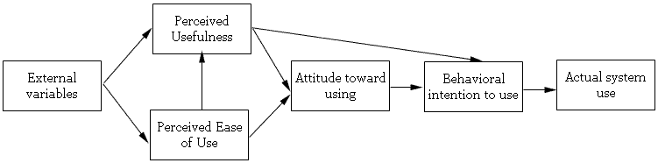

**External variables:**

External variables such as social influence are important factors in determining this attitude. When these things (TAM) are in place, people have attitudes and Intention to use artificial intelligence. However, the perception may change depending on the situation. Predisposition to technology, image, experience, spontaneity, quality of output, Expected Performance, Expected Effort, Social Impact, Age, Gender.

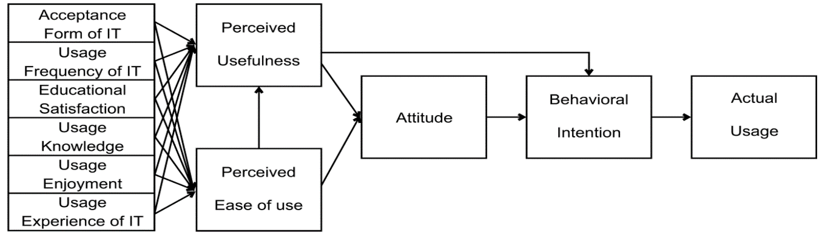

**Perceived usefulness :**

Perceived usefulness is defined as the degree to which a person believes that Using the system improves performance.

Perceived benefits depend on many factors.

* Relationship with research
* Learning outcomes
* Integration with other sources
* Personal preference

**Perceived usability of use:**

Perceived usability refers to how much people believe in its use. Artificial intelligence made easy It depends on several factors:

* Student background and past experience with AI
* AI tool design and user interface
* Compatibility of AI with existing systems and processes